153rd Annual
BLACKSTOCK FAIR
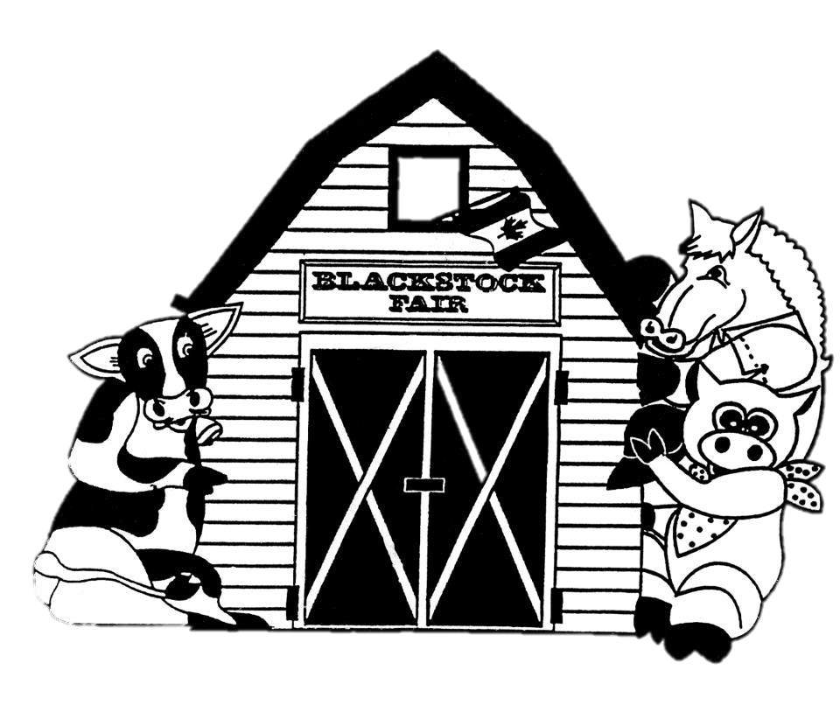
AUGUST 25TH, 2018.
Homecraft Classes
www.blackstockfair.org
Rules and Regulations
- No membership fee will be charged either before of after the fair. Exhibitors and their helpers will be charged admission to the fair.
- Entry forms must be submitted to the Secretary by Saturday, August 18.
- A late entry fee of $2 per class for livestock and $5 per exhibitor for other classes may be charged. Deletions and additions are permitted without penalty.
- Exhibitors will be limited to only one entry per class except for livestock classes where exhibitors may enter a maximum of 2 animals in each section.
- All exhibits in grasses, grains, and vegetables must be grown by the exhibitor, in Ontario, in the present year.
- The Rec Centre will be open to receive entries Thursday August 23, from 7-8pm and Friday August 24 from 8-11:30am. No exhibits will be accepted after 11:30am Friday August 24.
- All exhibitors of animals must have liability insurance.
- In the opinion of a judge, any animals or entry entered in the wrong class or does not comply with the rules and regulations, it shall be the duty of the judge to rule it out.
- Any person who uses abusive language or interferes with a judge because of a decision shall forfeit all rights to any prizes to which he or she may be entitled.
- Diligence will be exercised by the Directors to prevent injury, damage or loss of animals and entries. Should any article be accidentally injured, stolen or lost the Directors will render all assistance in their power towards its recovery but will not be bound to make any payment to the value thereof.
- Any exhibitor lodging a protest must place it in writing to the Secretary within one day. It must state plainly the cause of the complaint and must be accompanied by a deposit of $10.00 which will be forfeited to the Society if the protest is not sustained.
- Directors reserve the right to substitute a special prize that may be offered for any regular prize.
- The Rec Centre will close to the public at 5pm on Saturday August 25 and will re-open at 5:00pm for the pick-up of entries.
- The Society has always paid prizes in full. However, if the receipts are insufficient to cover the full amount, the Society reserves the right to pay on a percentage basis.
Premises ID: ON4228738
BLACKSTOCK AGRICULTURAL SOCIETY
44.1055290757667
-78.8214690048511

Homecraft- Class K
Homecraft President- Steven Backs
All entries to be in to Secretary by Saturday August 18. The Rec Centre will be open Thursday August 23, 7-8pm and Friday August 24, 8-11:30am.
No exhibits will be accepted after 11:30am Friday, August 24th.
Only one entry per class. All work must be clean, made since last Blackstock Fair and the work of the exhibitor. All knit articles must be hand knit. Sewing can be any size. When there are 6 or more exhibits a 4th place will be awarded. Quilts may be shown for 2 years. No straight pins to be used.
Exhibits can be collected at 5:00pm Saturday August 25th.
Prizes: 1st- $4 2nd- $3 3rd- $2
- Baby’s 2 pc. Outfit, knitted, not mounted
- Baby’s 2 pc. Outfit, crocheted, not mounted
K 1&2 Sponsored by Never Enough Wool
- Baby’s shawl or carriage cover, fine or bulky, knitted or crocheted
Sponsored by Never Enough Wool, Port Perry
- Cardigan, knitted
- Child’s pullover with sleeves, knitted
- Knit vest or sleeveless sweater
- Adult’s sweater, patterned
- Article of knit or crochet by a beginner (less than 2 years experience)
- Mitts or gloves, knitted
- Adult headgear, knitted
- Scarf
- Socks, knitted, pinned together
- Child’s hat
- Any other article, crocheted, not listed
- Any other article, knitted, not listed
- Slippers
MOST POINTS- Knitting $25 Gift Certificate
MOST POINTS- Crocheting $25 Gift Certificate
Sponsored by Never Enough Wool
- Nightwear
- Sundress or sleeveless dress
- Dress with sleeves
- Skirt, any length
- Dog coat
- Blouse or shirt
- Vest, sewn
- Poncho
- Cushion, fancy, fabric
- Cushion, novelty
- Cushion, any other variety
- Doily/Centrepiece, knitted or crocheted, mounted
- Article of polar fleece
- Two dishcloths
- Runner or dresser scarf
- Pillowcase or tea towel
- Article of counted cross stitch, not framed
- Two placemats with matching napkins
- Apron, any style
- Tea cozy
- Two quilt blocks (12” minimum), mounted, named
Afghans
Prizes: 1st- $5 2nd- $4 3rd- $3
- Afghan or lap robe or prayer shawl, knitted
- Afghan or lap robe or prayer shawl, crocheted
Community Service Challenge
(to benefit local charities)
This year please knit or crochet a scarf, any colour, size or pattern. All scarves will be donated to a local charity.
These articles will be displayed but not judged. Therefore, no prizes will be awarded. Please include your name with your donation.
Unsure of how to start? Call Never Enough Wool for more information (905) 985-0030.
Quilts
Prizes: 1st- $8 2nd- $7 3rd- $6
- Baby quilt, panel
- Baby quilt, any other
- Rag quilt
- Quilt, machine quilted, include name of quilt pattern
- Quilt, pieced, hand quilted, include name of quilt pattern
- Quilt, made by exhibitor, custom machine quilted, name pattern
- Quilt top
- Quilt, any other, include name of quilt pattern
- Cheater quilt, quilted
MOST POINTS- K 38-40, $25 Gift Certificate
Sponsored by Mary Maxim
Ontario Association of Agricultural Societies
Machine Quilted Competition
Prizes: 1st- $6 2nd- $5
Quilt/wall hanging total perimeter must be a minimum of 192”. The winner at Blackstock Fair is eligible to enter the quilt in the Fall District 4 Competition. The first prize quilt from District 4 is then entered in the O.A.A.S Competition which takes place at the Annual Convention in February.
Ontario Association of Agricultural Societies
Hand Quilted Competition
Prizes: 1st- $6 2nd- $5
Quilt/wall total perimeter must be a minimum of 324”. The winner at Blackstock Fair is eligible to enter the quilt in the Fall District 4 Competition. The first prize quilt from District 4 is then entered in the O.A.A.S Competition which takes place at the Annual Convention in February.
Golden Age- Class GA
Sponsored by Port Perry Dental Centre
open to exhibitors 60 years of age or older
Prizes: 1st- $4 2nd- $3 3rd- $2
- 3 Bran muffins, with raisins
- 3 Butter tarts, with raisins
- 3 tea biscuits, plain
- Your favourite loaf
- 5 of your favourite cookies (1 variety)
- Handwriting- poem, 12 lines or less
- Item for a bazaar to be sold for $10 or less
- Hand knit article
- Wooden article, not more than 24”
- Hand crocheted article
- Gift for a grandchild
- 3 photos mounted and labelled
- Any other craft not listed above
- Single serving of crisp
Crafts- Class C
All hangings should be ready to hang
Prizes: 1st- $4 2nd- $3 3rd- $2
- Wall-hanging, any media
- Handmade jewellery, mounted
- Door decoration, not Christmas
- Greeting card, using scrapbooking techniques
- Scrapbooking, one page enclosed in plastic
- Something new from something useless
- Stuffed toy
- Reusable shopping bag
- Article of original art, any media
- Wreath for front door, not Christmas
- Article of any other craft, not listed

T’was the Night Before Christmas
Sponsored by Port Perry Dental Centre
- Christmas tree decoration, 4” or smaller
- Christmas table runner
- 2 Christmas placemats
- Christmas article made from natural material
- Christmas apron
- Christmas stocking, any material
- Christmas gift bag, made of fabric
- Christmas door decoration
- Christmas angel
- Christmas article not listed above
Special Needs Adults- 21 years and over
- Craft of your choice
- Handmade card
- 3 Chocolate Chip cookies on a plate
Bernardin Special
- Bernardin SNAP Lid/Mason Jar Creative Craft Award
Best decorative or functional homemade craft made using a Bernardin mason jar(s) and/or 2-piece SNAP lid.
Prize- 1st $20 Gift Certificate
Bernardin Special
- Housewarming gift. Must include at least 3 Bernardin mason jars.
Prize- 1st $20 Gift Certificate

Culinary Arts- Class L
Sponsored by Gay Lea
No cake mixes, or commercial pie fillers allowed. Please use plastic bags where possible. No cake pans allowed. Paper liners to be removed before showing. Use smallest plate possible. No more than 1” of cardboard to be showing around the edges of any article. When there are 6 or more exhibits in a class a 4th place will be awarded. Please securely fasten all tags.
Baking
Prizes: 1st- $4 2nd- $3 3rd- $2
- White bread
- Bread, using a bread machine
- Whole wheat bread, 60%
- 5 Tea Biscuits with fruit
- 3 Apple cinnamon muffins
- 3 Banana chocolate chip muffins
- 3 Bran muffins
- 3 Any other muffins, named
- 5 Chocolate chip cookies
- 5 Gingersnaps/ ginger cookies
- 5 Oatmeal cookies with raisins
- 5 Peanut Butter cookies
- 5 Chocolate macaroons
- Banana Loaf- ½ loaf
- Blueberry loaf- ½ loaf
- Lemon loaf- ½ loaf
- Pumpkin loaf- ½ loaf
- Zucchini loaf- ½ loaf
- Any other loaf, named- ½ loaf
- Banana cake, iced
- 5 Date squares
- 5 Squares any other, named
- 3 Butter Tarts with raisins
Winner is eligible for the District 4 Competition
- Single pie pastry crust
- Blueberry pie
- Pie, any other variety, not needing refrigeration, named
- 5 pieces of Chocolate fudge with nuts
- 5 pieces Maple cream fudge
MOST POINTS BAKING- L 1-28, $25
Sponsored by Port Perry Royal Bank
Canning
All entries must be in sealed jars, except freezer jam. Unsealed jars will not be judged.
Prizes: 1st- $3.50 2nd- $3 3rd- $2.50
- Peach conserve with cherries
- Strawberry jam, cooked
- Rhubarb jam, any variety, named
- Any other jam, named, not listed in prize book
- Freezer jam, any variety, named
- Pepper jelly or relish
- Jelly, any variety, named
- Applesauce
- Canned fruit, any variety, named
- Bread and butter pickles
- Dill pickles
- Nine day or icicle pickles
- Pickles, any variety not listed, named
- Pickled beets
- Hot dog relish
- Chili sauce
- Salsa
- Boiled Salad Dressing
MOST POINTS CANNING- L 29-46, $25
Sponsored by Port Perry Royal Bank

SPECIALS Baking and Canning
- Bernardin Special- Best in Show
Judge’s choice of Best Home Canning Entry. Entry must be submitted in sealed Bernardin mason jars and snap lid. Prize- 1st- $30 gift certificate
- Bernardin Jam/Jelly Special- Marmalade
made with Bernardin fruit pectin product. Proof of purchase required. Certo is not a Bernardin product. Prize- 1st- $20 gift certificate
- Canned Peaches Special- In memory of Don Bradburn
Sponsored by Friends of Don Prizes- 1st- $12 2nd- $8 3rd- $5
- Crosby Molasses BBQ Sauce Special- 500ml
Sauce must include a minimum of ¼ cup of molasses. To be judged on taste, texture and creative use of a recipe. Label from product container to be submitted with BBQ sauce. Prizes- 1st- $15 2nd- $10 3rd- $5
- Marcelle’s Kitchen- Vegan Dessert Sponsored by John Redman
Please include your recipe. 1st place dessert goes to the sponsor.
Prizes- 1st- $15 2nd- $10 3rd- $5
- Gerald Kelly Memorial Chocolate Cake Special
Sponsored by the Kelly family
Chocolate layer cake iced. Champion cake will become the property of the Fair to be auctioned. Prizes- 1st- $50 2nd- $30 3rd- $20
- Edna Van Camp Memorial Raspberry Pie
Sponsored by Bill Van Camp in memory of his grandmother
1st place goes to the sponsor
Prizes- 1st- $25 2nd- $20 3rd- $15 $6 to show
- Dorothy Lee Memorial Cherry Pie Special
Sponsored by Dorothy Lee’s Family
Cherry Pie with hand-woven lattice top. Champion pie will become the property of the Fair to be auctioned. Prizes- 1st- $15 2nd- $10 3rd- $5
- Elva Van Camp Memorial Special- Cherry Loaf
Sponsored by Elva Van Camp’s Family
1st place goes to the sponsor Prizes- 1st- $20 2nd- $15 3rd- $10 4th-$5
- Lawrence and Jan Van Camp Special
Sponsored by Lawrence and Jan Van Camp
6 Shortbread cookies. 1st places goes to the sponsor. Please include your recipe. Prizes- 1st- $25 2nd- $15 $5 to show
- Eleanor Werry Memorial Special Sponsored by the Werry family
6 Chocolate brownies- without nuts, iced
Prizes- 1st- $20 2nd- $15 3rd- $10 4th-$5
- Leah Frew Special- Dark Fruit Cake Sponsored by Leah Frew
One layer 8” x 8” decorated for a wedding. Judged on both taste and decoration. 1st and 2nd prize goes to the sponsor.
Prizes- 1st- $75 2nd- $60 3rd- $15
- Barbara Byers Memorial Special
Sponsored by Barbara Byers’ family
Chiffon cake iced, any variety, named, must contain oil. Champion cake will become the property of the Fair to be auctioned.
Prizes- 1st- $20 2nd- $15 3rd- $10 4th-$5
- Crosby Molasses Cookie Special
6 Cookies made with molasses, must have min. ¼ cup of molasses. Made with Crosby molasses product. Label from product container to be submitted with cookies. Prizes- 1st- $15 2nd- $10 3rd- $5
- Crosby Molasses Cake Special
Cake made with molasses (including gingerbread): 8” x 8”. Cake must include a minimum of ¼ cup of molasses. To be judged on taste, texture and creative use of a recipe. Label from product container to be submitted with cake. Prizes- 1st- $15 2nd- $10 3rd- $5
- Crisco Special
3 Morning Glory Muffins, including product label
Prize- 1st- $25 gift certificate 2nd- $10 gift certificate
- Robin Hood Family Favourite Recipe- 3 Chocolate Chip Muffins
recipe included
Prize- 1st- $25 gift certificate 2nd- $10 gift certificate
- Robin Hood Family Best Lunchbox Snack- 5 Coconut Raspberry Squares
recipe included Prize- 1st- $25 gift certificate 2nd- $10 gift certificate
- Apple Pie Special: Sponsored by Dr. Paul Puckrin
All entries are to be brought to the fair on Saturday, August 25th to the Recreation Centre stage by 12:30 p.m. Judging will commence at 1:30 p.m. in front of the stage. All entries will become the property of the sponsor. All participants MUST be entered prior to the fair.
Prize: 1st - $100. 2nd - $30. 3rd - $20.

