154rd Annual
BLACKSTOCK FAIR
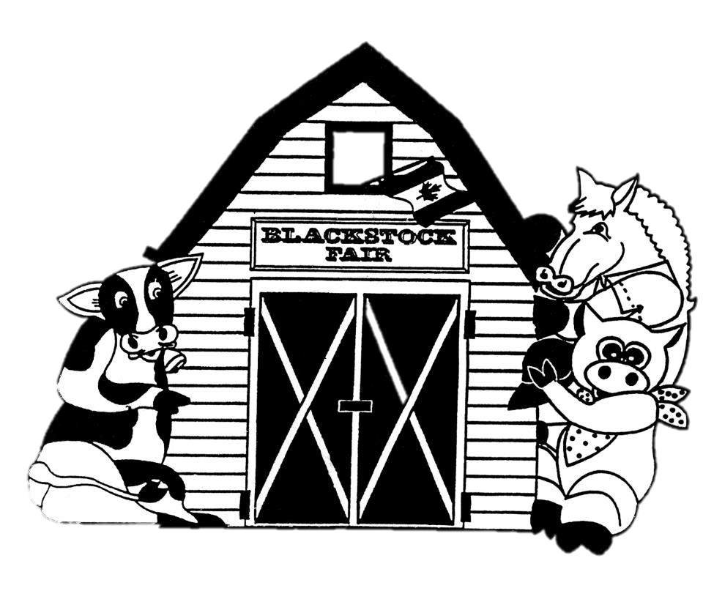
AUGUST 24TH, 2019.
Homecraft Classes
www.blackstockfair.org
Rules and Regulations
- No membership fee will be charged either before of after the fair. Exhibitors and their helpers will be charged admission to the fair.
- Entry forms must be submitted to the Secretary by Saturday, August 17.
- A late entry fee of $2 per class for livestock and $5 per exhibitor for other classes may be charged. Deletions and additions are permitted without penalty.
- Exhibitors will be limited to only one entry per class except for livestock classes where exhibitors may enter a maximum of 2 animals in each section.
- All exhibits in grasses, grains, and vegetables must be grown by the exhibitor, in Ontario, in the present year.
- The Rec Centre will be open to receive entries Thursday August 22, from 7-8pm and Friday August 23 from 8-11:30am. No exhibits will be accepted after 11:30am Friday August 23.
- All exhibitors of animals must have liability insurance.
- In the opinion of a judge, any animals or entry entered in the wrong class or does not comply with the rules and regulations, it shall be the duty of the judge to rule it out.
- Any person who uses abusive language or interferes with a judge because of a decision shall forfeit all rights to any prizes to which he or she may be entitled.
- Diligence will be exercised by the Directors to prevent injury, damage or loss of animals and entries. Should any article be accidentally injured, stolen or lost the Directors will render all assistance in their power towards its recovery but will not be bound to make any payment to the value thereof.
- Any exhibitor lodging a protest must place it in writing to the Secretary within one day. It must state plainly the cause of the complaint and must be accompanied by a deposit of $10.00 which will be forfeited to the Society if the protest is not sustained.
- Directors reserve the right to substitute a special prize that may be offered for any regular prize.
- The Rec Centre will close to the public at 4pm on Saturday August 24 and will re-open at 4:30pm for the pick-up of entries.
- The Society has always paid prizes in full. However, if the receipts are insufficient to cover the full amount, the Society reserves the right to pay on a percentage basis.
Premises ID: ON4228738
BLACKSTOCK AGRICULTURAL SOCIETY
44.1055290757667
-78.8214690048511

Homecraft- Class K
Homecraft President- Steven Backs
All entries to be in to Secretary by Saturday August 17. The Rec Centre will be open Thursday August 22, 7-8 p.m. and Friday August 23, 8-11:30 a.m.
No exhibits will be accepted after 11:30 a.m. Friday, August 23rd. Exhibits can be collected at 4:30 p.m. Saturday August 24th.
Only one entry per class. All work must be clean, made since last Blackstock Fair and the work of the exhibitor. All knit articles must be hand knit. Sewing can be any size. When there are 6 or more exhibits a 4th place will be awarded. Quilts may be shown for 2 years. No straight pins to be used.
Prizes: 1st- $4 2nd- $3 3rd- $2
- Baby’s 2 pc. outfit, knit or crocheted, not mounted
- Baby’s shawl or carriage cover, fine or bulky, knitted or crocheted
- Cardigan, knit or crocheted
- Pullover, knit or crocheted
- Article of knitting or crocheting by a beginner, less than 2 years experience
- Mitts or gloves, knit
- Mitts or gloves, crocheted
- Scarf, knit or crocheted
- Socks, knit or crocheted
- Headgear, knit or crocheted
- Scarf, knit or crocheted
- Child’s headgear, knit or crocheted
- Doily or centerpiece, knit or crocheted, mounted
- Slippers, knit or crocheted
- Two dishcloths, knit or crocheted
- Unique knitted article
- Unique crocheted article
- Sewn article with sleeves
- Poncho
- Runner or dresser scarf
- Apron
- Tea cozy
- 2 quilt blocks, mounted, pattern(s) named
Afghans
Prizes: 1st- $5 2nd- $4 3rd- $3

- Afghan, lap robe or prayer shawl, knit or crocheted
Sponsored by Jennifer Griffin, Farm Girl Creations
Quilts
Prizes: 1st- $8 2nd- $7 3rd- $6
Sponsored by Nestleton Waters Inn
- Baby’s quilt
- Rag quilt
- Quilt, machine quilted, pattern named
- Quilt, hand quilted, pattern named
- Cheater quilt, quilted
- Quilt made by a group, group to be named
- Quilt top
Classes K 1 and 2 sponsored by Never Enough Wool.
Classes K 18 and 19 sponsored by Brenda Jones.
MOST POINTS—Crocheting, Classes 1-15--$25—Never Enough Wool.
MOST POINTS—Knitting, Classes 1-15--$25—Never Enough Wool.
Ontario Association of Agricultural Societies
Machine Quilted Competition
Prizes: 1st- $6 2nd- $5
Chosen from eligible quilts in Classes 25 or 27. Must be made and machine quilted by exhibitor, total perimeter must be minimum 324”. Pattern must be named. The winner at Blackstock Fair is eligible to enter the quilt at the fall District 4 competition. Winner at District level is entered into O.A.A.S. competition which takes place at Annual Convention in February.
Ontario Association of Agricultural Societies
Hand Quilted Competition
Prizes: 1st- $6 2nd- $5
Chosen from eligible quilts in Classes 25 or 27. Must be made and hand quilted by exhibitor, total perimeter must be minimum 324”. Pattern must be named. The winner at Blackstock Fair is eligible to enter the quilt at the fall District 4 competition. Winner at District level is entered into O.A.A.S. competition which takes place at Annual Convention in February.
Golden Age- Class GA
Sponsored by Port Perry Dental Centre
Open to exhibitors 60 years of age or older
Prizes: 1st- $4 2nd- $3 3rd- $2
- Banana muffins, plain, 3
- Butter tarts, plain , 3
- Tea biscuits, plain, 3
- Cupcakes, any variety, 3
- Cookies, baked, any variety, 3
- Single serving of crisp
- Handwriting, first verse of O Canada
- Item suitable for bridal or baby shower
- Article of knitting
- Article of crocheting
- Gift for a grandchild
- Adult colouring page, coloured
- Design a card for a milestone birthday, any media including computer

Community Service Challenge to benefit local charities
Knit or crochet a hat, any colour, size or pattern. All hats will be donated to a local charity. These articles will be displayed but not judged. No prizes will be awarded. Please include your name with your hat.
Unsure of how to start?
Call Never Enough Wool for more information (905) 985-0030.

Crafts- Class C
Sponsored by Homestead Furniture and Appliances
All hangings should be ready to hang.
Prizes: 1st- $4 2nd- $3 3rd-$2
- Wall hanging, any media
- Article of handmade jewellery, mounted
- Door decoration
- Greeting card
- Adult colouring page, coloured
- Something new from something useless
- Article of counted cross stitch
- Reusable shopping bag or tote
- Article of original art, any media
- Article of any other craft, not listed
‘Tis the Season, any holiday
Sponsored by Port Perry Dental Centre
- Christmas tree decoration, 4” or smaller
- Holiday runner
- Wreath
- Trick or treat or gift bag
- Decorated Easter egg
- Holiday apron
- Door decoration
- Christmas stocking
- Holiday card
- Holiday article not listed above

Special Needs, 21 years and over
- Craft of your choice
- Greeting card
- Article of jewellery, mounted
- Oatmeal raisin cookies, 3
- Bernardin Special Best decorative or functional homemade craft made using a Bernardin mason jar(s) and/or 2-piece SNAP lid. Prize- 1st $20 Gift Certificate
- Bernardin Special Housewarming gift. Must include at least 3 Bernardin mason jars. Prize- 1st $20 Gift Certificate
Baking and Canning- Class L
Sponsored by Gay Lea Foods
No cake mixes or commercial pie fillers allowed. Please use plastic bags where possible. No cake pans allowed. Paper liners to be removed before showing. Use smallest plate possible. No more than 1” of cardboard to be showing around the edges of any article. When there are 6 or more exhibits in a class a 4th place will be awarded. Please securely fasten all tags.
Baking
Prizes: 1st- $4 2nd- $3 3rd- $2
- Yeast bread, any variety, ½ loaf
- Tea biscuits with fruit, 3
- Fruit muffins, named, 3
- Banana chocolate chip muffins, 3
- Bran muffins, 3
- Muffins, any variety, named, 3
- Oatmeal raisin cookies, 3
- Peanut butter cookies, 3
- Chocolate macaroons, 3
- Lemon loaf, ½ loaf
- Pumpkin loaf, ½ loaf
- Banana loaf, ½ loaf
- Any other loaf, named, ½ loaf
- Coffee cake, any variety, named
- Raspberry coconut squares, 3
- Squares, any other variety, named, 3
- Butter tarts, with raisins, 3
Winner is eligible for the District 4 Competition
- Fruit tarts, named, 3
- Single pie crust
- Apple pie
- Any other pie, named
- Your favourite candy, named, 3 pieces
- Decorated cupcakes, agricultural theme, 3
MOST POINTS BAKING- L 1-22, $25
Sponsored by Port Perry Royal Bank
Canning
All entries must be sealed except freezer jam. Unsealed jars will not be judged.
Prizes: 1st- $3.50 2nd- $3 3rd- $2.50
- Strawberry jam, cooked
- Marmalade, any variety, named
- Any other jam, named
- Freezer jam, any variety, named
- Jelly, any variety, named
- Spirited jam or jelly, named
- Canned fruit, any variety, named
- Pickled vegetable, any variety, named
- Pickled cucumber, any variety, named
- Dill pickles, any variety
- Any other pickle, not listed, named
- Hot dog relish
- Chili sauce
- Salsa
Bernardin Best of Show—Judge’s choice of best home canning entry from Classes 23-36. Entry must be submitted in sealed Bernardin jar and snap lid.
Prize--$30 gift certificate
MOST POINTS CANNING- L 29-46, $25
Sponsored by Port Perry Royal Bank
SPECIALS Baking and Canning
- Bernardin Jam/Jelly Special- Raspberry Jam or Jelly
made with Bernardin fruit pectin product. Proof of purchase required. Certo is not a Bernardin product. Prize- 1st- $20 gift certificate
- Crosby Molasses BBQ Sauce 500ml Sauce must include a minimum of ¼ cup of molasses. To be judged on taste, texture and creativity. Label and recipe required. Prizes- 1st- $15 2nd- $10 3rd- $5
- Marcelle’s Kitchen- Keto Dessert Sponsored by John Redman
Please include your recipe. 1st place dessert goes to the sponsor.
Prizes- 1st- $15 2nd- $10 3rd- $5
- Eleanor Werry Memorial Special Sponsored by the Werry family
6 Chocolate brownies- without nuts, iced
Prizes- 1st- $20 2nd- $15 3rd- $10 4th-$5
- Gerald Kelly Memorial Chocolate Cake Special
Sponsored by Gerald Kelly’s family
Chocolate layer cake, iced. Champion cake will become the property of the Fair to be auctioned. Prizes- 1st- $50 2nd- $30 3rd- $20
- Edna Van Camp Memorial Raspberry Pie
Sponsored by Bill Van Camp in memory of his grandmother
1st place goes to the sponsor
Prizes- 1st- $25 2nd- $20 3rd- $15 $6 to show
- Dorothy Lee Memorial Cherry Pie Special
Sponsored by Dorothy Lee’s family
Cherry Pie with hand-woven lattice top. Champion pie will become the property of the Fair to be auctioned. Prizes- 1st- $15 2nd- $10 3rd- $5
- Elva Van Camp Memorial Special- Cherry Loaf
Sponsored by Elva Van Camp’s family
1st place goes to the sponsor Prizes- 1st- $20 2nd- $15 3rd- $10 4th-$5
- Lawrence and Jan Van Camp Special
Sponsored by Lawrence and Jan Van Camp
6 Shortbread cookies. 1st place goes to the sponsor. Please include your recipe. Prizes- 1st- $25 2nd- $15 $5 to show
- Leah Frew Special- Dark Fruit Cake Sponsored by Leah Frew
One layer, 8” x 8”, iced. 1st and 2nd prize goes to the sponsor.
Prizes- 1st- $75 2nd- $60 3rd- $15
- Barbara Byers Memorial Special Sponsored by Barbara Byers’ family
Chiffon cake iced, any variety, named, must contain oil. Champion cake will become the property of the Fair to be auctioned.
Prizes- 1st- $20 2nd- $15 3rd- $10 4th-$5
- Dale VanCamp Memorial Special Sponsored by Dale VanCamp’s family
Lemon Bundt cake, iced or glazed. 1st place cake to sponsor
Prizes—1st--$50 2nd--$25 3rd--$15 4th--$10
- Crosby Molasses Cookie Special
6 Cookies made with minimum of ¼ cup molasses. Label and recipe required. Prizes- 1st- $15 2nd- $10 3rd- $5
- Crosby Molasses Cake Special
Cake made with minimum ¼ cup molasses (including gingerbread): 8” x 8”. To be judged on taste, texture and creative use of a recipe. Label and recipe required. Prizes- 1st- $15 2nd- $10 3rd- $5
- Crisco Special
3 Morning Glory Muffins, including label and recipe.
Prize- 1st- $25 gift certificate 2nd- $10 gift certificate
- Robin Hood Family Favourite Recipe- 3 Lemon Muffins
Label and recipe included .
Prize- 1st- $25 gift certificate 2nd- $10 gift certificate
- Robin Hood Family Best Lunchbox Snack- 5 Butter Tart Squares
Recipe and label included
Prize- 1st- $25 gift certificate 2nd- $10 gift certificate
- Hummingbird Cake Sponsored by Dr. Paul Puckrin
All entries are to be brought to the fair on Saturday, August 24th to the Recreation Centre stage by 12:30 p.m. Judging will commence at 1:30 p.m. in front of the stage. All entries will become the property of the sponsor. All participants MUST be entered prior to the fair.
Prize: 1st - $100. 2nd - $30. 3rd - $20.

