153rd Annual
BLACKSTOCK FAIR
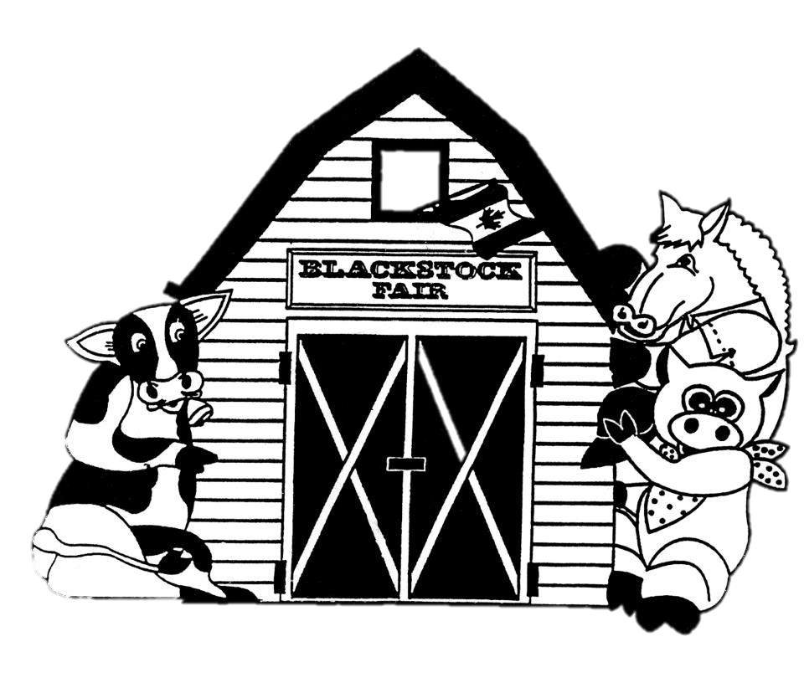
AUGUST 25TH, 2018.
Horse Classes
www.blackstockfair.org
Rules and Regulations
- No membership fee will be charged either before of after the fair. Exhibitors and their helpers will be charged admission to the fair.
- Entry forms must be submitted to the Secretary by Saturday, August 18.
- A late entry fee of $2 per class for livestock and $5 per exhibitor for other classes may be charged. Deletions and additions are permitted without penalty.
- Exhibitors will be limited to only one entry per class except for livestock classes where exhibitors may enter a maximum of 2 animals in each section.
- All exhibits in grasses, grains, and vegetables must be grown by the exhibitor, in Ontario, in the present year.
- The Rec Centre will be open to receive entries Thursday August 23, from 7-8pm and Friday August 24 from 8-11:30am. No exhibits will be accepted after 11:30am Friday August 24.
- All exhibitors of animals must have liability insurance.
- In the opinion of a judge, any animals or entry entered in the wrong class or does not comply with the rules and regulations, it shall be the duty of the judge to rule it out.
- Any person who uses abusive language or interferes with a judge because of a decision shall forfeit all rights to any prizes to which he or she may be entitled.
- Diligence will be exercised by the Directors to prevent injury, damage or loss of animals and entries. Should any article be accidentally injured, stolen or lost the Directors will render all assistance in their power towards its recovery but will not be bound to make any payment to the value thereof.
- Any exhibitor lodging a protest must place it in writing to the Secretary within one day. It must state plainly the cause of the complaint and must be accompanied by a deposit of $10.00 which will be forfeited to the Society if the protest is not sustained.
- Directors reserve the right to substitute a special prize that may be offered for any regular prize.
- The Rec Centre will close to the public at 5pm on Saturday August 25 and will re-open at 5:00pm for the pick-up of entries.
- The Society has always paid prizes in full. However, if the receipts are insufficient to cover the full amount, the Society reserves the right to pay on a percentage basis.
Premises ID: ON4228738
BLACKSTOCK AGRICULTURAL SOCIETY
44.1055290757667
-78.8214690048511

Horses- Class A
Chair- Jennifer Griffin (289) 385-3814
Exhibitors are allowed 2 entries per section.
Line classes will begin showing at 8:30am.
Hitch classes will be shown following the fair parade at approximately 11:15am. See order of show attached.
All exhibitors of animals MUST have liability insurance included on their entry form. Please sign waiver when submitting your entry form.
No membership fees will be charged but all exhibitors WILL be charged admission to the fair.
Light Horses
Welsh Pony- Class AL1
1. Leadline Under saddle $30. 25. 20. 15. 10.
2. Welsh A/B under saddle $30. 25. 20. 15. 10.
3. Cob under saddle $30. 25. 20. 15. 10.
4. Welsh A driving $30. 25. 20. 15. 10.
5. Welsh B/C/D driving $30. 25. 20. 15. 10.
6. Junior driver $30. 25. 20. 15. 10.
Roadster Horses- Class AL2
1. Single Roadster, under 15.2 $40. 35. 30. 25. 20.
2. Single Roadster, 15.2 and over $40. 35. 30. 25. 20.
3. Team of Roadster Horses $50. 45. 40. 35. 30.
4. Single Roadster to a bike, under 15.2 $40. 35. 30. 25. 20.
5. Single Roadster to a bike, 15.2 and over $40. 35. 30. 25. 20.
6. Lady Driver, 16 years and over $40. 35. 30. 25. 20.
7. Gentleman’s Turnout $40. 35. 30. 25. 20.
Harness Ponies- Class AL3
1. Single Harness Pony $40. 35. 30. 25. 20.
2. Roadster Pony $40. 35. 30. 25. 20.
3. Roadster Pony Stake $50. 45. 40. 35. 30.
4. Fine Harness Pony Stake $50. 45. 40. 35. 30.
5. Pleasure Driving Stake $50. 45. 40. 35. 30.
Heavy Horses
Draft/Commercial/Halflinger Line Classes- Class AH1
Line classes will be shown in the order below. (Draft will consist of Belgians, Clydesdales and Percherons showing together)
Prizes- 1st-$25 2nd-$20 3rd-$15 4th-$10 5th-$10
- Draft- filly or colt foaled in 2018
- Halflinger- filly or colt foaled in 2018
- Draft- yearling filly or colt foaled in 2017
- Halflinger- yearling filly or colt foaled in 2017
- Draft- 2 year old filly or colt foaled in 2016
- Halflinger- 2 year old filly or colt foaled in 2016
- Draft or Commercial gelding or grade mare- light
- Halflinger gelding or grade mare
- Draft or Commercial gelding or grade mare heavy
- Halflinger mare 3 and over
- Junior Showmanship (18 years and under)
All breeds together Prize- $10 to show
- Costume Class- Theme
All breeds together Prize $10 to show
Sponsored by Philip and Jennifer McLeod
Draft/Commercial/Halflinger Horses in Harness- Class AH2
Hitch lasses will be shown in order of showing. (Draft will consist of Belgians, Clydesdales and Percharons showing together)
- Single Draft $30. 25. 20. 15. 10.
- Single Light Commercial $30. 25. 20. 15. 10.
- Single Halflinger $30. 25. 20. 15. 10.
- Junior Driver-single- all breeds together $50. 45. 40. 35. 35.
- Single Heavy Commercial $30. 25. 20. 15. 10.
- Light Draft Team $50. 45. 40. 35. 35.
- Light Commercial Team $50. 45. 40. 35. 35.
- Light Halflinger Team $50. 45. 40. 35. 35.
- Lady Driver Team (all breeds together) $55. 45. 40. 35. 35.
Trophy donated by Jennifer Griffin
in memory of her Aunt Lorna Davey
- Best Matched Team- Draft & Commercial $50. 45. 40. 35. 35.
- Heavy Draft Team $50. 45. 40. 35. 35.
- Heavy Commercial Team $50. 45. 40. 35. 35.
- Heavy Halflinger Team $50. 45. 40. 35. 35.
- Unicorn hitch- Draft and Commercial $75. 70. 65. 60. 55.
- Unicorn hitch- Halflinger $75. 70. 65. 60. 55.
- Four Horse- Draft and Commercial $80. 75. 70. 65. 60.
- Four Horse- Halflinger $80. 75. 70. 65. 60.
- Draft, Commercial & Halflinger Horse Under Saddle
Prize $20 to show
Sponsored by Jennifer and Jason Griffin
Saddle Horses
All rider must wear approved riding helmets and safe, correct footwear.
Horses and ponies will be shown together. Open to all horses and ponies. English and Western disciplines welcome. Attire and equipment should be appropriate to the discipline. For example, if you are showing in Western Tack the rider must turn out in Western Attire. Jackets will be excused in all games classes.
Prizes- 1st-$20 2nd-$18 3rd-$16 4th-$14 5th-$12
SPECIAL- An award will be given for each division high point winner
Lead Line Class- AS1
Open to all riders 11yrs and under as of Jan 1, 2018. To be judged 25% on neatness and turnout of the rider and mount, 75% judged on the rider’s performance. Riders must be lead by a parent or handler 16 years or older. Riders in AS1 may not enter in AS2 or AS3 classes.
- Lead Line Walk Only
- Lead Line Walk/Trot
Beginner Walk/Trot- Class AS2
Open to riders 7 to 17yrs as of Jan 1, 2018. Riders over 14 yrs. must have proof of age. Riders may not have won 1st in any other competition other than lead line classes. Riders in class AS2 may not enter in AS1 or AS3 classes.
- Beginner Walk/Trot Pleasure
- Beginner Walk/Trot Equitation
Novice Walk/Trot- Class AS3
Open to riders 17yrs and under as of Jan 1, 2018. Riders in class AS3 may not enter AS1 or AS2.
- Novice Walk/Trot/Canter Pleasure
- Novice Walk/Trot/Canter Equitation
Senior Walk/Trot- Class AS4
Open to riders 18yrs and over as of Jan 1, 2018.
- Senior Walk/Trot/Canter Pleasure
- Senior Walk/Trot/Canter Equitation
Showmanship and Fun- Class AS5
Horses may enter multiple cases with different handlers.
- Youth Showmanship (11 years and under as of Jan 1, 2018)
- Junior Showmanship (12 to 17 years as of Jan 1, 2018)
- Senior Showmanship (18 years and over as of Jan 1, 2018)
- Costume Class- riders and mount are to be dressed in their costumes of choice. The best/most creative costume wins. Handlers are allowed.

ORDER OF SHOW BLACKSTOCK FAIR 2018
*** PLEASE NOTE THAT IF THERE IS ONLY 1 ENTRY IN THE DRAFT, COMMERCIAL & HALFLINGER CLASSES, THOSE CLASSES MAY BE COMBINED ***
***CLASSES WILL BE STOPPING ROUGHLY AROUND 11:15AM FOR THE PARADE TO COME THROUGH ***
- Youth Showmanship
- Junior Showmanhip
- Senior Showmanship
- Leadline Walk Only
- Leadline Walk / Trot
- Welsh Pony Leadline under saddle
- Beginner Walk / Trot Pleasure
- Beginner Walk / Trot Equitation
- Draft Filly or colt foaled in 2018
- Halflinger filly or colt foaled in 2018
- Draft yearling filly foaled in 2017
- Halflinger yearling foaled in 2017
- Draft 2 year old filly foaled in 2016
- Halflinger 2 year old filly foaled in 2016
- Draft or Commercial gelding or grade mare – light
- Halflinger gelding or grade mare
- Draft or Commercial gelding or grade mare – heavy
- Halflinger mare 3 & over
- Junior Showmanship ( 18 yrs & under as of January 1st, 2018)
All breeds show together DRAFT, COMMERCIAL & HALFLINGER
- Novice Walk / Trot / Canter Pleasure
- Novice Walk / Trot / Canter Equitation
- Costume Class – Sponsor Phillip & Jennifer Mc Leod
All breeds show together
- Costume Class Light Horse Divison
- Single Harness Pony
- Single Roadster under 15.2
- Senior Walk / Trot / Pleasure Equitation
- Single Draft
- Single Light Commercial
- Single Halflinger
- Welsh A/B under saddle
- Single Roadster 15.2 & over
- Junior Driver – Single – ALL BREEDS TOGETHER, DRAFT, COMMERCIAL & HALFLINGER
- Single Heavy Commercial
- Roadster Pony
- Light Draft Team
- Light Commercial Team
- Light Halflinger Team
- Welsh Cob under saddle
- Team of Roaster Horses
- Roadster Pony Stake
- Lady Driver Team -- ALL BREEDS TOGETHER, DRAFT, COMMERCIAL & HALFLINGER
- Best Matched Team – Draft & Commercial
- Heavy Draft Team
- Heavy Commercial Team
- Heavy Halflinger Team
- Welsh A driving
- Single Roaster to bike, under 15.2
- Fine Harness Pony Stake
- Welsh b/c/d driving
- Pleasure Driving Stake
- Single Roadster to bike 15.2 & over
- Welsh Pony Junior Driver
- Unicorn Hitch – Draft & Commercial
- Roadster Lady driver –16 years of age & over
- Unicorn – Halflinger
- Gentleman’s Turnout
- Four Horse Hitch -- Draft & Commercial
- Four Horse Hitch – Halflinger
- Draft & Commercial Horse Under Saddle

