153rd Annual
BLACKSTOCK FAIR
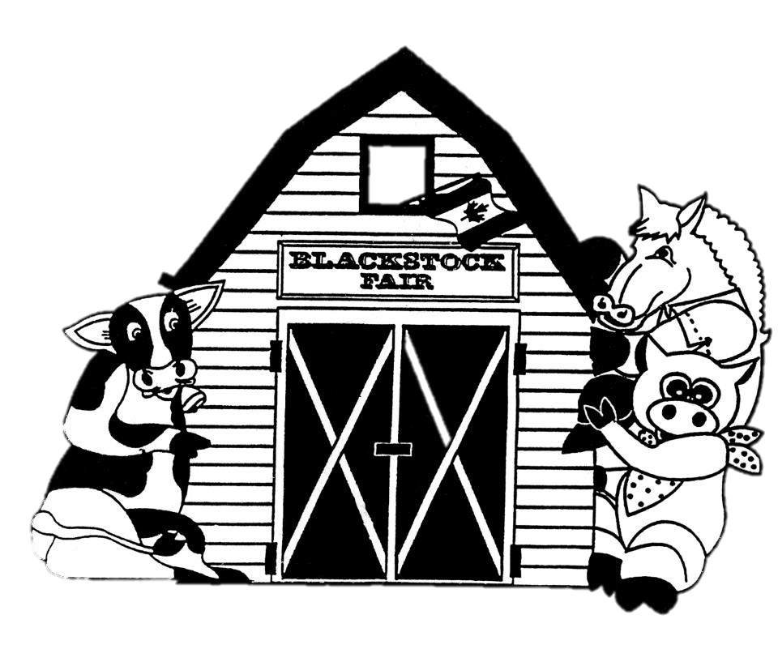
AUGUST 25TH, 2018.
Junior Classes
www.blackstockfair.org

Note: Junior exhibitors may also enter in adult classes.
Rules and Regulations
- No membership fee will be charged either before of after the fair. Exhibitors and their helpers will be charged admission to the fair.
- Entry forms must be submitted to the Secretary by Saturday, August 18.
- A late entry fee of $2 per class for livestock and $5 per exhibitor for other classes may be charged. Deletions and additions are permitted without penalty.
- Exhibitors will be limited to only one entry per class except for livestock classes where exhibitors may enter a maximum of 2 animals in each section.
- All exhibits in grasses, grains, and vegetables must be grown by the exhibitor, in Ontario, in the present year.
- The Rec Centre will be open to receive entries Thursday August 23, from 7-8pm and Friday August 24 from 8-11:30am. No exhibits will be accepted after 11:30am Friday August 24.
- All exhibitors of animals must have liability insurance.
- In the opinion of a judge, any animals or entry entered in the wrong class or does not comply with the rules and regulations, it shall be the duty of the judge to rule it out.
- Any person who uses abusive language or interferes with a judge because of a decision shall forfeit all rights to any prizes to which he or she may be entitled.
- Diligence will be exercised by the Directors to prevent injury, damage or loss of animals and entries. Should any article be accidentally injured, stolen or lost the Directors will render all assistance in their power towards its recovery but will not be bound to make any payment to the value thereof.
- Any exhibitor lodging a protest must place it in writing to the Secretary within one day. It must state plainly the cause of the complaint and must be accompanied by a deposit of $10.00 which will be forfeited to the Society if the protest is not sustained.
- Directors reserve the right to substitute a special prize that may be offered for any regular prize.
- The Rec Centre will close to the public at 5pm on Saturday August 25 and will re-open at 5:00pm for the pick-up of entries.
- The Society has always paid prizes in full. However, if the receipts are insufficient to cover the full amount, the Society reserves the right to pay on a percentage basis.
Premises ID: ON4228738
BLACKSTOCK AGRICULTURAL SOCIETY
44.1055290757667
-78.8214690048511
Preschool and Kindergarten- Class W
Sponsored by Vos' Independent Grocer, Port Perry
Note to Parents: All work MUST be done by the exhibitor. Parents should encourage their children but ALLOW THEM TO DO THE WORK THEMSELVES. Open to all children. No entry fees. Children may show in older classes.
All entries to be in to Secretary by Saturday August 18. The Rec Centre will be open Thursday August 23, 7-8pm and Friday August 24, 8-11:30am.
No exhibits will be accepted after 11:30am Friday, August 24th.
Prizes: 1st- $2 2nd- $1.75 3rd- $1.50 4th-$1.25 5th-$1 6th-$0.75
Pre-School- Age 3 and under, as of Jan 1, 2018.
- Finger Painting- max 30 x 45cm
- Collage of stickers
- 6 Rocks displayed in ½ egg carton, no lid
- Colour picture of a farm animal
- Largest leaf mounted on paper (max 30 x 45cm)
- Decorated tracing of your foot
- Animal face on a paper plate
Children younger than or finishing Junior Kindergarten in June 2018
- Picture made using a Bingo Dabber or stamp
- Collection of 6 nature items displayed in egg carton with no lid
- Draw a picture of a farm animal
- Picture of a Turkey using your Handprint no larger than 30 x 45 cm
- Make a necklace using beads or buttons
- Print "Barn" and decorate the page
Children younger than or finishing Senior Kindergarten in June 2018
- Print "Farm Friends" judged on printing (max 30 x 45 cm)
- Make a sheep using your hand print and cotton balls
- Make a picture of a Tractor using cereal
- Collection of 3 leaves that are different shapes mounted on paper
- Draw and colour a picture of yourself (max 30 x 45 cm)
- Make a farm picture using stickers
Junior - Class T
Junior Craft
Sponsored by Vos Independent Grocer, Port Perry
Children 7 and under as of June 2018.
Prizes: 1st- $2 2nd- $1.75 3rd- $1.50 4th-$1.25 5th-$1 6th-$0.75
- Neatly Print “Baa Baa Black Sheep"
- Rock decorated like a cow
- Barn made from Popsicle sticks (can be decorated)
- Draw and Colour a picture of a Farm Animal
- Dryer Lint Monster displayed on a paper plate - Decorations Allowed
- Make a bug using a wooden clothes pin or any other medium
Children 10 and under as of Jan 1, 2018.
Prizes: 1st- $2 2nd- $1.75 3rd- $1.50 4th-$1.25 5th-$1 6th-$0.75
- Make a stained-glass picture using Tissue paper
- Print
"Old McDonald had a farm, E - I - E - I - O,
and on his farm he had a pig, E - I - E - I - O,
With an Oink, Oink Here, And an Oink, Oink There."
- Article made from Duct Tape
- Farm Animal using Marshmallows
- School Project
- Article made from Popsicle Sticks
- Airplane made using recycled material (scrap lumber, shoe box, etc.)
Children 14 and under as of Jan 1, 2018.
Prizes: 1st- $2.50 2nd- $2.25 3rd- $1.75 4th-$1.50 5th-$1
- Scrapbook page
- Original artwork, any medium
- Free Hand Drawing of a Hockey team logo (max. 8 ½ x 11)
- Robot made from any medium (cereal boxes, plastic cup, cans etc.)
- Create a decoration or center piece using a Farm Theme
- Print or handwrite the 4H pledge, judged on penmanship
- School project from 2017-2018 school year
Children 18 and under as of Jan 1, 2018.
Prizes: 1st- $2.50 2nd- $2.25 3rd- $1.75 4th-$1.50 5th-$1
- Short story or poem using the theme farm and agriculture
- Original artwork, any medium, can be school project
- String art
- Create a poster promoting Farming "Farm Gate to Dinner Plate"
- Design a page for an Adult colouring book
- Model made from a Kit, Plastic or wood (Can be Lego)
- Make a Christmas Tree Ornament (Can be from a kit)
Special Needs Children 14 and under as of Jan 1, 2018.
Prizes: 1st- $2.50 2nd- $2.00 3rd- $1.50 4th-$1.00 5th-$0.50
- Decorated Clay pot
- Colour a picture of a farm scene
- 3 chocolate chip cookies on a plate
Special Needs Children 21 and under as of Jan 1, 2018.
Prizes: 1st- $2.50 2nd- $2.00 3rd- $1.50 4th-$1.00 5th-$0.50
- Christmas tree ornament
- Design a page for an adult colouring book
- 3 chocolate chip cookies on a plate
Youth Poster Competition
Theme: Promoting Your Fair
Prizes: 1st- $5 2nd- $4 3rd- $3
- Three Classes
a) Junior up to and including Grade 4
b) Intermediate Grade 5 to Grade 8
c) Senior Grade 9 to Grade 12
Poster size: maximum 8 1/2 “x 11” (23x28cm) without border.
Must be hand drawn. Each entry must be centered on a Cardstock of Bristol board with a 5cm border on all sides.
Winner is eligible for the District 4 Competition!
Junior Baking
Sponsored by Vos Independent Grocer, Port Perry
Prizes: 1st- $3.00 2nd- $2.50 3rd- $2.00 4th-$1.50 5th-$1.00
Children 10 and under as of Jan 1, 2018.
- One cupcake, decorated, judged on decoration only, mix allowed
- 3 Brownies, mix allowed
- Rice Krispies creation
Children 14 and under as of Jan 1, 2018.
- 3 Squares, any variety, named
- 3 Chocolate Chip Cookies, no nuts
- 1 Sugar cookie, decorated, judged on decoration only, mix allowed
Children 18 and under as of Jan 1, 2018.
- 3 Chocolate Chip Cookies, no nuts
- 3 Brownies
- One cupcake, decorated, judged on decoration only, mix allowed
Chocolate Chip Cookie Competition
Open to all children 15 years and under as of Jan 1, 2018
Prizes: 1st- $5.00 2nd- $4 3rd- $3
- 5 Chocolate Chip Cookies, no nuts, no larger than 3” and no smaller than 2”.
Winner is eligible for the District 4 Competition!
ONO Lego Special
- Create an original Lego Structure (no kits). Bring it in built. Size to be determined by builder.
Prizes: 1st- $10 $5.00 to show.
  - Children 7 years of and under by Dec. 31, 2017.
  - Children 10 years of age and under by Dec. 31, 2017.
Photography Class H
Sponsored by Focus on Scugog
Chair- Janet VanCamp (905) 986-0097
All 4”x6” coloured prints to be mounted on a maximum 6”x8” white background. All photographs must be taken by the exhibitor.
Junior Section- 18yr and under
- A “Selfie”
- Fun Times
- I Love My Family
- Farm Animal(s)
Specials: Open to All Ages
Prizes: 1st- $6 2nd- $4 3rd- $2
- 4H in Days Gone By (state year if possible, black and white or colour, any size)
- Remember When (black and white or colour, any size)
- Farming Today (black and white or colour, 4x6)
Junior Vegetables- Class JV
Sponsored by Murray Hill Farm
Open to children age pre-school to Grade 8. Tags must be securely fastened.
Prizes- 1st-$3 2nd-$2 3rd-$1.25 4th-$1
- 6 Beans, any colour
- 3 Carrots, 1” top
- 3 Cherry tomatoes
- 3 Peppers, any colour
- 1 Zucchini, 6”-12” long
- Longest bean
- Longest Zucchini
- Longest carrot
- Longest tomato
- Decorated vegetable using natural materials
Junior Flowers- Class JF
Open to children age pre-school to Grade 8.
Prizes- 1st-$2.50 2nd-$2 3rd-$1.50 4th-$1 5th- 0.75 6th-0.50
- Marigolds, 3 blooms, over 2” (5cm)
- Hosta, 3 leaves, variegated, same variety
- Hosta, 3 leaves, non-variegated, same variety
- Hydrangea, 1 stem
- Rose, 1 bloom
- Rudbeckia (Black eyed Susan), 3 blooms
- Sunflower Head, max 12”
- Zinnia, 3 blooms
- Any other Annual, 1 spray or bloom
- Any other Perennial, 1 spray or bloom
- Any Potted Plant
Junior Flower Arrangements
JF 12-15 Sponsored by Grace Bajema
Prizes- 1st-$4 2nd-$3.50 3rd-$3 4th-$2.50 5th- $2
- “Summer Sunshine”- an arrangement using mainly yellow flowers
- “Pick & Plunk” a collection of seasonal material picked and artfully plunked into a container of your choice.
- “Make it Simple”- an arrangement using different types of foliage, no flowers
- “Ditch Treasures”- an arrangement of wild flowers, bulrushes, leaves and/or grasses in a container of your choice
Most Points: JF 1-15 1st-$12 2nd-$8 3rd-$5
Sponsored by Pine Ridge Garden Club

2018 Opening Parade
Chairs- Barry VanCamp and Steven Backs (905) 914-0007
** PLEASE NOTE** All adults participating in the parade will have the opportunity to purchase their wrist band at a reduced rate of $5.00.
All drivers of vehicles or individuals riding animals must sign a waiver to participate in the parade. The Fair Board will not be responsible for any accidents which may occur during the Parade.
DO NOT THROW CANDY!
Parade to leave the Cartwright Central Public School at 10:30 a.m. sharp. Please assemble by 9:30 a.m. for placement.
There is NO parade theme this year. We want everyone to use their imagination!
Prizes- $25 TO SHOW (Classes 1 – 9)
- Comic Costume
- Comic Group
- Decorated Bicycle ridden by a child over 8 years of age.
- Decorated Bicycle or Tricycle ridden by a child under 8 years of age.
- Decorated Doll Carriage or Wagon
- Novelty Outfit worn by a child.
- Vintage costumes worn by couple walking in parade. (Wear a sign showing year)
- Vintage costume worn by a person walking in the parade. (Wear a sign showing year)
- Antique Car or Truck
- Pleasure Class, Saddle Horse or Pony
- Vintage Tractor, with working brakes for safety
$25.00 TO SHOW Sponsored by the family of Lorne McKee
Prizes- $75 TO SHOW (Classes 12 – 13)
- Decorated Commercial Float - drawn by vehicle.
- Decorated Float – Non-commercial 8’ and up – Family float
- Mini Float, up to 8’, excluding tractor.

Kid’s World
Chair- Mary Meyer (905) 259-5725
Air Bounce Inflatables are returning.
Go to Kid’s World to purchase your play all day wristband.
Enjoy these great activities for FREE!
Face painting Hair colour spray Calf hutch play house
Craft table Corn play table Hay obstacle course
Pedal Tractor Pull
Sponsored by Trewin Farm Equipment
All participants must pre-register the day of the fair at Kid’s World. Children will be divided into the following weight categories. Limit of 15 children per weight category.
- 40lbs and under
- 40-55lbs
- 55-70lbs
1st, 2nd, and 3rd places will receive a trophy and all other participants will receive a ribbon.

Durham East 4-H Clubs
Animals should be on the fairgrounds by 9:30am
4-H Achievement Day starts at 10:00am
Durham East 4-H Goat Club
Durham East 4-H Sheep Club
Durham East 4-H Beef Club
Sponsored by: Dow Seeds, Craig Carson, Territory Sales Rep
(905) 440-0505
Durham East 4-H Swine Club
Durham West 4-H Mini Tractor Pulling
Each member will receive $5 for exhibiting their animal.
Sponsored by the Blackstock Agricultural Society
Durham East 4-H Woodworking Club
The woodworking club for their achievement day will be displaying their projects in the arena. Each member will receive $5 for exhibiting.
Sponsored by Lake Scugog Lumber, Port Perry
4-H Club Exhibits
- Open to any 4H Club in the Durham East 4H Council Area.
- Exhibits must reflect the subject area of a 2018 or Fall 2017 topic.
- Each club may place one exhibit at the Fair.
- Exhibits should be placed on display between 10 and 11:30am on Friday August 24 and remain on display until 5pm Saturday August 25.
- Exhibits will be judged.
Prizes: $15 $12 $10 $5 to show
Sponsored by Lake Scugog Lumber, Port Perry

Champion Showperson Competition
Sponsored by Tim Campbell, Territory Manager for Gallagher Fencing Systems.
Prizes: 1st-$75 2nd- $65 3rd- $60 4th- $50
This competition will take place immediately following the last showmanship competition listed above at approximately 3:30pm. Competitors will receive a cash prize on the day of the event.
Participants
Open to 1st place overall show person in Beef, Dairy, Goat & Sheep competition as chosen by the judges in their respective classes on the day of the fair. Not necessarily a 4-H member.
Requirements
Each participant will be required to show each of the four animals
Effort will be made to ensure that the animals used in each class are NOT the 4-H projects of any of the participants.
Participants will be judged on their showmanship ability with each animal. The competition will be held in the beef ring following the completion of breed specific classes. The competition will be judged by the judges from each of these classes during the fair. Points will be assigned to each competitor as follows: 1st: 10 2nd: 7 3rd: 5 4th: 3
In the event of a tie the score of the class that the exhibitor won to earn them a spot in this competition will be dropped from the scoring. If required, final decision on the overall placement will be based on the discretion of the panel of judges.

Saddle Horses
All rider must wear approved riding helmets and safe, correct footwear.
Horses and ponies will be shown together. Open to all horses and ponies. English and Western disciplines welcome. Attire and equipment should be appropriate to the discipline. For example, if you are showing in Western Tack the rider must turn out in Western Attire. Jackets will be excused in all games classes.
Prizes- 1st-$20 2nd-$18 3rd-$16 4th-$14 5th-$12
SPECIAL- An award will be given for each division high point winner
Lead Line Class- AS1
Open to all riders 11yrs and under as of Jan 1, 2018. To be judged 25% on neatness and turnout of the rider and mount, 75% judged on the rider’s performance. Riders must be lead by a parent or handler 16 years or older. Riders in AS1 may not enter in AS2 or AS3 classes.
- Lead Line Walk Only
- Lead Line Walk/Trot
Beginner Walk/Trot- Class AS2
Open to riders 7 to 17yrs as of Jan 1, 2018. Riders over 14 yrs. must have proof of age. Riders may not have won 1st in any other competition other than lead line classes. Riders in class AS2 may not enter in AS1 or AS3 classes.
- Beginner Walk/Trot Pleasure
- Beginner Walk/Trot Equitation
Novice Walk/Trot- Class AS3
Open to riders 17yrs and under as of Jan 1, 2018. Riders in class AS3 may not enter AS1 or AS2.
- Novice Walk/Trot/Canter Pleasure
- Novice Walk/Trot/Canter Equitation
Senior Walk/Trot- Class AS4
Open to riders 18yrs and over as of Jan 1, 2018.
- Senior Walk/Trot/Canter Pleasure
- Senior Walk/Trot/Canter Equitation
Showmanship and Fun- Class AS5
Horses may enter multiple cases with different handlers.
- Youth Showmanship (11 years and under as of Jan 1, 2018)
- Junior Showmanship (12 to 17 years as of Jan 1, 2018)
- Senior Showmanship (18 years and over as of Jan 1, 2018)
- Costume Class- riders and mount are to be dressed in their costumes of choice. The best/most creative costume wins. Handlers are allowed.

Beef- Class B
Chairs- Fred Taylor (905) 986-4897 Nicole Beechey (289) 356-6707
- Showmanship- Open- Children 9 years of age and younger with beef animal (not eligible 4-H age)
Prize- $5 to show
Sponsored by Cedardale Charolais (The Nesbitt Family)
in memory of Keith Goble
Dairy
Chair- Glenn Barkey (905) 655-5812
Prizes- 1st-$10 2nd-$8 3rd-$6 4th-$5 $4 to show
- Showmanship- Pre-Novice under 9 yrs. Showing a dairy calf
- Showmanship- Novice 4-H, 9, 10 &11 years, showing a dairy calf
- Showmanship- Junior 4-H, 12-14yrs, showing a dairy calf
- Showmanship- Senior 4-H, 15-21yrs, showing a dairy calf
Classes 6-9 Sponsored by Port Perry Veterinary Services

