154rd Annual
BLACKSTOCK FAIR
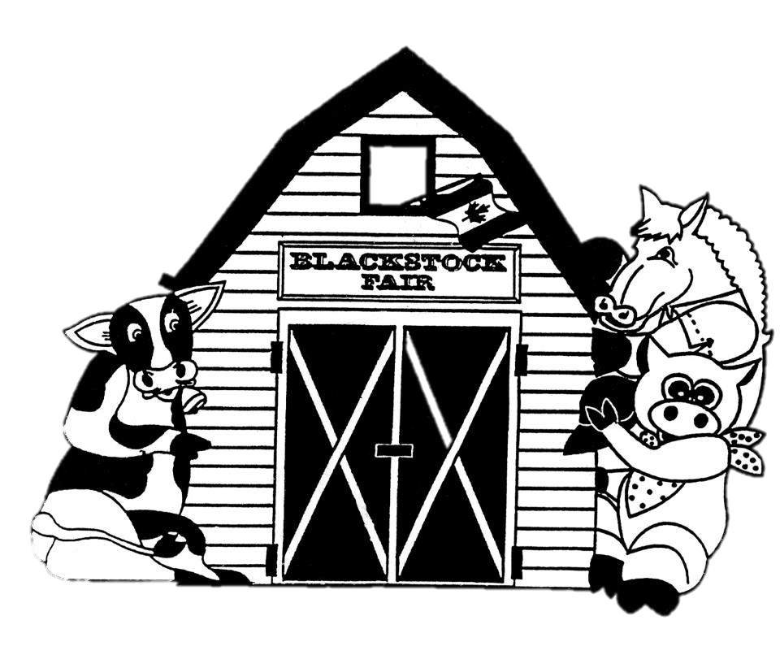
AUGUST 24TH, 2019.
Junior Classes
www.blackstockfair.org
Rules and Regulations
- No membership fee will be charged either before of after the fair. Exhibitors and their helpers will be charged admission to the fair.
- Entry forms must be submitted to the Secretary by Saturday, August 17.
- A late entry fee of $2 per class for livestock and $5 per exhibitor for other classes may be charged. Deletions and additions are permitted without penalty.
- Exhibitors will be limited to only one entry per class except for livestock classes where exhibitors may enter a maximum of 2 animals in each section.
- All exhibits in grasses, grains, and vegetables must be grown by the exhibitor, in Ontario, in the present year.
- The Rec Centre will be open to receive entries Thursday August 22, from 7-8pm and Friday August 23 from 8-11:30am. No exhibits will be accepted after 11:30am Friday August 23.
- All exhibitors of animals must have liability insurance.
- In the opinion of a judge, any animals or entry entered in the wrong class or does not comply with the rules and regulations, it shall be the duty of the judge to rule it out.
- Any person who uses abusive language or interferes with a judge because of a decision shall forfeit all rights to any prizes to which he or she may be entitled.
- Diligence will be exercised by the Directors to prevent injury, damage or loss of animals and entries. Should any article be accidentally injured, stolen or lost the Directors will render all assistance in their power towards its recovery but will not be bound to make any payment to the value thereof.
- Any exhibitor lodging a protest must place it in writing to the Secretary within one day. It must state plainly the cause of the complaint and must be accompanied by a deposit of $10.00 which will be forfeited to the Society if the protest is not sustained.
- Directors reserve the right to substitute a special prize that may be offered for any regular prize.
- The Rec Centre will close to the public at 4pm on Saturday August 24 and will re-open at 4:30pm for the pick-up of entries.
- The Society has always paid prizes in full. However, if the receipts are insufficient to cover the full amount, the Society reserves the right to pay on a percentage basis.
Premises ID: ON4228738
BLACKSTOCK AGRICULTURAL SOCIETY
44.1055290757667
-78.8214690048511

Kids’ World
Chair- Mary Meyer (905) 259-5725
Air Bounce Inflatables are returning.
Go to Kids’ World to purchase your play all day wristband.
Enjoy these great activities for FREE!
Face painting Hair colour spray Colouring table
Toddlers’ play area Corn play table Hay obstacle course
Sunflower Growing Contest
Open to elementary school students and younger. Entries to be at Kids’ World by 11 a.m. Fair Day. Please have tag with name and class attached. All children entering a sunflower will receive a treat.
Class 1 Tallest sunflower
Class 2 Biggest head/flower
Class 3 Smallest head/flower
Prizes will be awarded by 3 p.m.

Pedal Tractor Pull
Sponsored by Trewin Farm Equipment
All participants must pre-register the day of the fair at Kid’s World. Children will be divided into the following weight categories. Limit of 15 children per weight category.
- 40 lbs and under
- 40-55 lbs
- 55-70 lbs
1st, 2nd, and 3rd places will receive a trophy and all other participants will receive a ribbon.

Saddle Horses

Prizes- 1st-$20 2nd-$18 3rd-$16 4th-$14 5th-$12
SPECIAL—An award will be given for each division high point winner.
All riders must wear approved riding helmets and safe, correct footwear. Horses and ponies will be shown together. Open to all horses and ponies. English and Western disciplines welcome. Attire and equipment should be appropriate to the discipline. For example, if you are showing in Western Tack, the rider must turn out in Western attire. Jackets will be excused in all games classes.
Lead Line Class Open to all riders 11 years and under, as of Jan 1, 2019. To be judged 25% on neatness and turnout of the rider and mount, 75% judged on the rider’s performance. Riders must be led by a parent or handler, 16 years or older. Riders in Classes 47 and 48 may not enter in Classes 49-54.
47. Lead line, walk only
48. Lead line, walk/trot
Beginner Walk/Trot Open to riders, 7-17 years, as of Jan. 1, 2019. Riders over 14 yrs. must have proof of age. Riders may not have won 1st in any other competition other than lead line classes. Riders in Classes 49 and 50 may not enter in Classes 47, 48, 51 or 52.
49. Beginner, Walk/Trot, pleasure
50. Beginner , Walk/Trot, equitation
Novice Walk/Trot Open to riders 17 years and under, as of Jan. 1, 2019. Riders in Classes 51 and 52 may not enter in Classes 47-50.
51. Novice, Walk/Trot/Canter, pleasure
52. Novice, Walk/Trot/Canter, equitation
Senior Walk/Trot Open to riders, 18 years and over, as of Jan. 1, 2019
53. Senior, Walk/Trot/Canter, pleasure
54. Senior, Walk/Trot/Canter, equitation

Showmanship and Fun
Horses may enter multiple classes with different handlers.
55. Youth Showmanship, 11 year and under, as of Jan. 1, 2019
56. Junior Showmanship, 12-17 years, as of Jan. 1, 2019
57. Senior Showmanship, 18 years and over, as of Jan. 1, 2019
58. Costume class, riders and mount to be dressed in costume of their choice. Best/most creative costume wins. Handlers allowed.
59. Spoon and egg race
60. Command class
Durham East 4-H Clubs
Animals should be on the fairgrounds by 9:30 a.m.
4-H Achievement Day starts at 10:00 a.m.
Durham East 4-H Goat Club
Durham East 4-H Sheep Club
Durham East 4-H Beef Club
Durham West 4-H Mini Tractor Pulling
Each member will receive $5 for exhibiting their animal.
Sponsored by the Blackstock Agricultural Society
Durham East 4-H Woodworking Club
The woodworking club for their achievement day will be displaying their projects in the arena. Each member will receive $5 for exhibiting.
Sponsored by Lake Scugog Lumber, Port Perry
4-H Club Exhibits
- Open to any 4H Club in the Durham East 4H Council Area.
- Exhibits must reflect the subject area of a 2019 or Fall 2018 topic.
- Each club may place one exhibit at the Fair.
- Exhibits should be placed on display between 10 and 11:30am on Friday August 23 and remain on display until 5pm Saturday August 24.
- Exhibits will be judged.
Prizes: $15 $12 $10 $5 to show
Sponsored by Lake Scugog Lumber, Port Perry

Champion Showperson Competition
Sponsored by Tim Campbell, Territory Manager for Gallagher Fencing Systems and Ryan Nesbitt.
Prizes: 1st-$75 2nd- $65 3rd- $60 4th- $50
This competition will take place immediately following the last showmanship competition listed above at approximately 3:30 p.m. Competitors will receive a cash prize on the day of the event.
Participants
Open to 1st place overall show person in Beef, Dairy, Goat & Sheep competition as chosen by the judges in their respective classes on the day of the fair. Not necessarily a 4-H member.
Requirements
Each participant will be required to show each of the four animals.
Effort will be made to ensure that the animals used in each class are NOT the 4-H projects of any of the participants.
Participants will be judged on their showmanship ability with each animal. The competition will be held in the beef ring following the completion of breed specific classes. The competition will be judged by the judges from each of these classes during the fair. Points will be assigned to each competitor as follows: 1st: 10 2nd: 7 3rd: 5 4th: 3
In the event of a tie the score of the class that the exhibitor won to earn them a spot in this competition will be dropped from the scoring. If required, final decision on the overall placement will be based on the discretion of the panel of judges.

Beef Showmanship
11. Showmanship- Open- Children 9 years of age and younger with beef animal (not eligible 4-H age)
Prize- $5 to show
Sponsored by Cedardale Charolais (The Nesbitt Family)
in memory of Keith Goble
Dairy Showmanship
Prizes- 1st-$10 2nd-$8 3rd-$6 4th-$5 $4 to show
- Pre-Novice, under 9 years, showing a dairy calf
- Novice 4-H, 9-11 years, showing a dairy calf
- Junior 4-H, 12-14 years, showing a dairy calf
- Senior 4-H, 15-21 years, showing a dairy calf
Classes 1-4 sponsored by Port Perry Veterinary Services
Classes 8-11 sponsored by Durham Holstein Club
Junior Vegetables- Class JV
Sponsored by Murray Hill Farm
Open to children age pre-school to Grade 8. Tags must be securely fastened.
Prizes- 1st-$3 2nd-$2 3rd-$1.50 4th-$1 5th--.75
- 6 Beans, any colour
- 3 Carrots, 1” top
- 3 Cherry tomatoes
- 3 Peppers, any colour
- 1 Zucchini, 6”-12” long
- Longest bean
- Longest Zucchini
- Longest carrot
- Longest tomato
- Decorated vegetable using natural materials
- Oddest shaped vegetable

Junior Flowers- Class JF
Open to children, Grade 8 and under
Prizes- 1st-$3 2nd-$2 3rd-$1.50 4th-$1 5th- 0.75
- Marigolds, 3 blooms, over 2” (5cm)
- Hosta, 3 leaves, variegated, same variety
- Hosta, 3 leaves, non-variegated, same variety
- Hydrangea, 1 stem
- Rose, 1 bloom
- Rudbeckia (Black eyed Susan), 3 blooms
- Sunflower Head
- Zinnia, 3 blooms
- Any other Annual, 1 spray or bloom
- Any other Perennial, 1 spray or bloom
- Any Potted Plant
Junior Flower Arrangements
JF 12-15 Sponsored by Grace Bajema
Prizes- 1st-$4 2nd-$3.50 3rd-$3 4th-$2.50 5th- $2
- “Coffee Time”- an arrangement in a coffee mug
- “Leafing Out”, an arrangement using different types of leaves
- “Mucking Around”, an arrangement using different types of wildflowers, grasses, bulrushes, etc. in a boot or shoe
- “Pick and Plunk”, a collection of seasonal garden grown material, picked and artfully plunked into container of your choice

Most Points: JF 1-15 1st-$12 2nd-$8 3rd-$5
Sponsored by Pine Ridge Garden Club

Photography Class H
Sponsored by Focus on Scugog
Chair- Janet VanCamp (905) 986-0097
All 4”x6” coloured prints to be mounted on a maximum 6”x8” white background. All photographs must be taken by the exhibitor.
Junior Section- 18yr and under
- Oops
- Wheel(s)
- The Colour Green
- Photo with Caption
Specials: Open to All Ages
Prizes: 1st- $6 2nd- $4 3rd- $2
- Durham Region landmark, named
- Farm Building(s)
- Wow! Mother Nature is incredible!
Preschool and Kindergarten- Class W
Sponsored by Vos' Independent Grocer, Port Perry
All work MUST be done by the exhibitor. Parents should encourage their children but ALLOW THEM TO DO THE WORK THEMSELVES. No entry fees. Children may show in older classes. All pictures to be maximum 30 x 45 cm. Entry forms to be in to Secretary by Saturday August 17. The Rec Centre will be open Thursday August 22, 7-8pm and Friday August 23,8-11:30am. No exhibits will be accepted after 11:30 a.m. Friday, August 23rd.
Prizes: 1st- $2 2nd- $1.75 3rd- $1.50 4th-$1.25 5th-$1 6th-$0.75
Pre-School- Age 3 and under, as of June 2019
- Finger Painting
- Colour a picture from a colouring book
- Largest leaf mounted on paper (max 30 x 45cm)
- Collection of 6 buttons displayed in ½ egg carton, no lid
- Decorate a rock
- Collage of stickers
- Decorated handprint using paint
Children younger than or finishing Junior Kindergarten in June 2019
- Collection of nature items display in egg carton, no lid
- Create a picture using thumbprints
- Caterpillar, butterfly, spider or bee from an egg carton
- Picture using a bingo dabber or stamp
- Drawing of a cat and print the word “Cat” on it
- Christmas decoration
Children younger than or finishing Senior Kindergarten in June 2019
- Draw and colour your favourite animal, labelled, max 30 x 45 cm
- Create a pattern using colours, max 30 x 45 cm
- Draw and colour a tractor, max. 30 x 45 cm
- Fall wreath of leaves and disposable plate
- Collection of 3 flowers, different shapes, mounted on paper
- Print “Blackstock Fair 2019”, judged on printing
Junior - Class T
Sponsored by Vos Independent Grocer, Port Perry
7 years and under, as of June 2019
- Collage of playground using torn paper and texture materials
- Rock decorated like a flower or bee
- Print “Having fun at Blackstock Fair 2019”, judged on printing
- Dragonfly, any medium, must be 3D
- House or cabin from popsicle sticks, can be decorated
- Painting of your favourite animal you see at the fair
10 years and under, as of June 1, 2019
26. Farm animal made from marshmallows
- Article made from popsicle sticks
- Alien from a disposable plate
- Decorate your first initial, not computer generated, any medium
- Duct tape article
- Picture of a bird using beads and/or buttons
- Print first verse of “O Canada”
Prizes: 1st- $2.50 2nd- $2.25 3rd- $1.75 4th-$1.50 5th-$1
14 years and under, as of June 1, 2019
- Farm vehicle made from candy
- Original artwork, any medium
- Free Hand Drawing of a team logo
- Time capsule in plastic container, decorated, 3 items
- Personal sized emergency kit in large zip bag
- One page letter, “What I will be in the future”
- Wooden article i.e. bird house, bird feeder
18 years and under, as of June 1, 2019
- Woodworking or metal art article
- Original poem
- Handmade article for craft show
- Jewellery, mounted
- Centrepiece of artificial flowers
- Original artwork of your favourite demo car or tractor pull tractor
- Welcome sign
Special Needs
Prizes: 1st- $2.50 2nd- $2.25 3rd- $1.75 4th-$1.50 5th-$1.
14 years and under, as of June 1, 2019
47. Beaded necklace, wearable
- “My Favourite Place” poster
- No bake squares, 3 of same kind
21 years and under, as of June 1, 2019
- Colour a page from an adult colouring book
- Painted Welcome sign
- Oatmeal raisin cookies, 3
Youth Poster Competition
Theme: Promoting Your Fair
Minimum 22 x 28 cm, maximum 28 x 44 cm (not including border)
Must be hand drawn. Each entry must be centered on card stock or bristol board with approximately 5.5 cm border on all sides.
Prizes: 1st- $5 2nd- $4 3rd- $3
Winner is eligible for the District 4 Competition!
- a) Junior, up to and including Grade 4
b) Intermediate, Grade 5 to Grade 8
c) Senior, Grade 9 to Grade 12

Junior Baking
Sponsored by Vos Independent Grocer, Port Perry
Prizes: 1st- $2.50 2nd- $2.25 3rd- $1.75 4th-$1.50 5th-$1.
10 years and under, as of June 1, 2019
- One cupcake, decorated, judged on decoration only
- Muffins, any variety, 3
- Rice Krispies creation
- Double chocolate cookies, 3
18 years and under, as of June 1, 2019
- Decorated cookie, judged on decoration and taste
- Unbaked squares, 3
- Brownies, no nuts, iced, no mixes, 3
- Thumbprint cookies, 3
Chocolate Chip Cookie Competition
Open to anyone 15 years and under, as of December 31, 2019
Prizes: 1st- $5.00 2nd- $4 3rd- $3
- Chocolate Chip Cookies, no nuts, 2-3”, 5
Winner is eligible for the District 4 Competition!
ONO Lego Special
Prizes: 1st--$10.00 $5.00 to show

Create an original Lego structure, no kits allowed. Bring in your structure completed. Size to be determined by builder
- 7 years and under, as of June 1, 2019
- 10 years and under, as of June 1, 2019

