153rd Annual
BLACKSTOCK FAIR
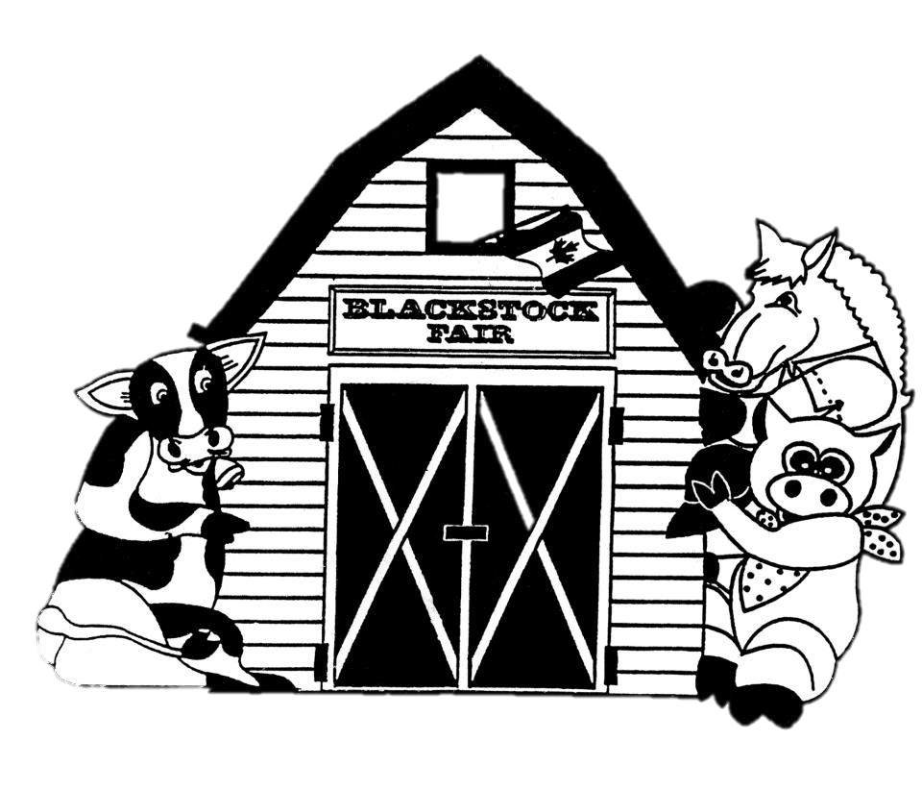
AUGUST 25TH, 2018.
Parade Classes
www.blackstockfair.org

Rules and Regulations
- No membership fee will be charged either before of after the fair. Exhibitors and their helpers will be charged admission to the fair.
- Entry forms must be submitted to the Secretary by Saturday, August 18.
- A late entry fee of $2 per class for livestock and $5 per exhibitor for other classes may be charged. Deletions and additions are permitted without penalty.
- Exhibitors will be limited to only one entry per class except for livestock classes where exhibitors may enter a maximum of 2 animals in each section.
- All exhibits in grasses, grains, and vegetables must be grown by the exhibitor, in Ontario, in the present year.
- The Rec Centre will be open to receive entries Thursday August 23, from 7-8pm and Friday August 24 from 8-11:30am. No exhibits will be accepted after 11:30am Friday August 24.
- All exhibitors of animals must have liability insurance.
- In the opinion of a judge, any animals or entry entered in the wrong class or does not comply with the rules and regulations, it shall be the duty of the judge to rule it out.
- Any person who uses abusive language or interferes with a judge because of a decision shall forfeit all rights to any prizes to which he or she may be entitled.
- Diligence will be exercised by the Directors to prevent injury, damage or loss of animals and entries. Should any article be accidentally injured, stolen or lost the Directors will render all assistance in their power towards its recovery but will not be bound to make any payment to the value thereof.
- Any exhibitor lodging a protest must place it in writing to the Secretary within one day. It must state plainly the cause of the complaint and must be accompanied by a deposit of $10.00 which will be forfeited to the Society if the protest is not sustained.
- Directors reserve the right to substitute a special prize that may be offered for any regular prize.
- The Rec Centre will close to the public at 5pm on Saturday August 25 and will re-open at 5:00pm for the pick-up of entries.
- The Society has always paid prizes in full. However, if the receipts are insufficient to cover the full amount, the Society reserves the right to pay on a percentage basis.
Premises ID: ON4228738
BLACKSTOCK AGRICULTURAL SOCIETY
44.1055290757667
-78.8214690048511

2018 Opening Parade
Chairs- Barry VanCamp and Steven Backs (905) 914-0007
** PLEASE NOTE** All adults participating in the parade will have the opportunity to purchase their wrist band at a reduced rate of $5.00.
All drivers of vehicles or individuals riding animals must sign a waiver to participate in the parade. The Fair Board will not be responsible for any accidents which may occur during the Parade.
DO NOT THROW CANDY!
Parade to leave the Cartwright Central Public School at 10:30 a.m. sharp. Please assemble by 9:30 a.m. for placement.
There is NO parade theme this year. We want everyone to use their imagination!
Prizes- $25 TO SHOW (Classes 1 – 9)
- Comic Costume
- Comic Group
- Decorated Bicycle ridden by a child over 8 years of age.
- Decorated Bicycle or Tricycle ridden by a child under 8 years of age.
- Decorated Doll Carriage or Wagon
- Novelty Outfit worn by a child.
- Vintage costumes worn by couple walking in parade. (Wear a sign showing year)
- Vintage costume worn by a person walking in the parade. (Wear a sign showing year)
- Antique Car or Truck
- Pleasure Class, Saddle Horse or Pony
- Vintage Tractor, with working brakes for safety
$25.00 TO SHOW Sponsored by the family of Lorne McKee
Prizes- $75 TO SHOW (Classes 12 – 13)
- Decorated Commercial Float - drawn by vehicle.
- Decorated Float – Non-commercial 8’ and up – Family float
- Mini Float, up to 8’, excluding tractor.

Fair Day Specials!
Please register at the fair office by 4:00 p.m. for the following specials.
Prizes- $25 for the winner of each special
SPECIAL 1 - Couple that have come the farthest distance to the fair
SPECIAL 2 - Person that has come the farthest distance to the fair
SPECIAL 3 - Couple married the longest
SPECIAL 4 – Couple married the shortest
SPECIAL 5 - Oldest person attending the fair
SPECIAL 6 - Youngest person attending the fair

NEW!
BACKSEAT DRIVING COMPETITION
Sponsored by Denise Aston, The Co-operators, Port Perry
Winning couple receives $100.
2nd Place couple receives $75.
3rd Place couple receives $50.
Tractor & wagon provided
- Contest is open to couples who are both over 16 years of age.
- One member of the couple will be the driver of a lawn tractor and will be blindfolded while the other member of the couple will sit in attached wagon giving directions through an obstacle course. Touching the driver will result in a disqualification.
- This is a timed event; each obstacle/pylon which is hit will result in a penalty of 5-seconds being added to actual time to determine the total time. Fastest total time is the winner.
- Decision of the judges is final. NO PROTEST

