154rd Annual
BLACKSTOCK FAIR
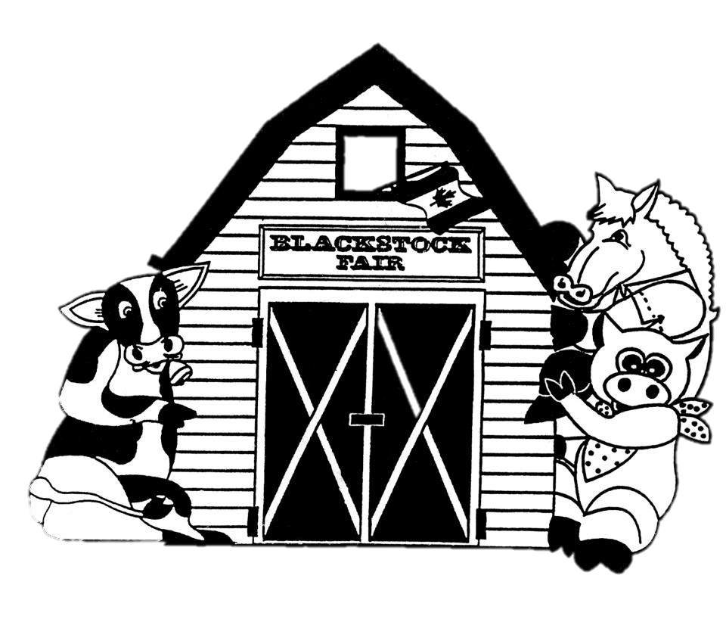
AUGUST 24TH, 2019.
Vegetables and Grains Classes
www.blackstockfair.org
Rules and Regulations
- No membership fee will be charged either before of after the fair. Exhibitors and their helpers will be charged admission to the fair.
- Entry forms must be submitted to the Secretary by Saturday, August 17.
- A late entry fee of $2 per class for livestock and $5 per exhibitor for other classes may be charged. Deletions and additions are permitted without penalty.
- Exhibitors will be limited to only one entry per class except for livestock classes where exhibitors may enter a maximum of 2 animals in each section.
- All exhibits in grasses, grains, and vegetables must be grown by the exhibitor, in Ontario, in the present year.
- The Rec Centre will be open to receive entries Thursday August 22, from 7-8pm and Friday August 23 from 8-11:30am. No exhibits will be accepted after 11:30am Friday August 23.
- All exhibitors of animals must have liability insurance.
- In the opinion of a judge, any animals or entry entered in the wrong class or does not comply with the rules and regulations, it shall be the duty of the judge to rule it out.
- Any person who uses abusive language or interferes with a judge because of a decision shall forfeit all rights to any prizes to which he or she may be entitled.
- Diligence will be exercised by the Directors to prevent injury, damage or loss of animals and entries. Should any article be accidentally injured, stolen or lost the Directors will render all assistance in their power towards its recovery but will not be bound to make any payment to the value thereof.
- Any exhibitor lodging a protest must place it in writing to the Secretary within one day. It must state plainly the cause of the complaint and must be accompanied by a deposit of $10.00 which will be forfeited to the Society if the protest is not sustained.
- Directors reserve the right to substitute a special prize that may be offered for any regular prize.
- The Rec Centre will close to the public at 4pm on Saturday August 24 and will re-open at 4:30pm for the pick-up of entries.
- The Society has always paid prizes in full. However, if the receipts are insufficient to cover the full amount, the Society reserves the right to pay on a percentage basis.
Premises ID: ON4228738
BLACKSTOCK AGRICULTURAL SOCIETY
44.1055290757667
-78.8214690048511

Grains and Grasses- Class G
Chair- Donald Fisher (289) 356-6707
All entries to be in to Secretary by Saturday August 17. All exhibits must be in the Arena before 11:30 a.m. Friday August 23rd. Only one entry per family will be allowed. All exhibits must be the present year’s crop except grain soybeans.
- Soft Red Winter Wheat, named, 2019, approx. 4 litres 10. 9. 8. 7.
- Hard Red Winter Wheat, named, 2019, approx. 4 litres 10. 9. 8. 7.
- Soft White Wheat, named, 2019, approx. 4 litres 10. 9. 8. 7.
- Oats, named, 2019, approx. 4 litres 10. 9. 8. 7.
- Grain Soybeans, named, 2018, approx. 4 litres 10. 9. 8. 7.
- Sheaf ensilage corn, named, 10 stalks, 7. 6. 5. 4.
- 10 cobs of Grain Corn, named 12. 10. 8. 6.
- Baled Hay, first cutting, 10” slice or equivalent 12. 10. 8. 6.
Sponsored by Bob Swain
- Baled Hay, second cutting, 10” slice or equivalent 12. 10. 8. 6.
- Haylage 12. 10. 8. 6.
- Whole plant soybean, named, specify row width, 10 7. 6. 5. 4.
Grain classes sponsored by Pioneer Hi-Bred Ltd. & Port Perry Seeds (Jim Roefs)
Vegetables- Class V
Sponsored by Linton’s Farm Market
Chair- Helen Coates (905) 985-3985
All entries to be in to Secretary by Saturday August 17. All exhibits must be in the Arena before 11:30 a.m. Friday August 23rd. Vegetables MUST be on paper plates unless otherwise specified. Tags must be securely fastened. Exhibits may be picked up Saturday August 24 at 4:30 p.m.
Prizes- 1st-$4 2nd-$3 3rd-$2
- 5 Potatoes, white, named
- 5 Potatoes, any other colour, named
- 2 Zucchini, maximum 12” long, stem on
- 2 Squash, not summer squash, stem on
- 6 Carrots, 1” tops
- 6 Onions, Dutch set, not skinned
- 4 Spanish Onions, not skinned
- 3 Sweet Peppers, any colour, stems on
- 6 Green beans
- 6 Beans, any other colour
- 6 Beets, round
- 6 Beets, cylindrical
- 6 Pickling cucumbers
- 3 Slicing cucumbers
- 4 Green tomatoes, min 2 ¼ “diameter, stems on
- 4 Red tomatoes, not plum, min 2 ¼ “diameter, stems on
- 4 Plum tomatoes, stems on
- 4 Ripe tomatoes, max 2 ¼ “diameter, stems on, any colour
- 3 Garlic, 1” top, roots trimmed
- 1 Oddly Shaped Vegetable
- Heirloom vegetable, named
Most Points in Classes V1-21, $25
sponsored by Cows and Cranio Farms, Peter and Elizabeth Peeters
Junior Vegetables- Class JV
Sponsored by Murray Hill Farm
Open to children age pre-school to Grade 8. Tags must be securely fastened.
Prizes- 1st-$3 2nd-$2 3rd-$1.50 4th-$1 5th--.75
- 6 Beans, any colour
- 3 Carrots, 1” top
- 3 Cherry tomatoes
- 3 Peppers, any colour
- 1 Zucchini, 6”-12” long
- Longest bean
- Longest Zucchini
- Longest carrot
- Longest tomato
- Decorated vegetable using natural materials
- Oddest shaped vegetable

NEW! Sunflower Growing Contest
Open to elementary school students and younger. Entries to be at Kids’ World by 11 a.m. Fair Day. Please have tag with name and class attached. All children entering a sunflower will receive a treat.
Class 1 Tallest sunflower
Class 2 Biggest head/flower
Class 3 Smallest head/flower
Prizes will be awarded by 3 p.m.

